Screenshots or program listings must be copied into appropriate cells in the following table.
Save this evidence document as evidence_ followed by your centre number_ candidate number. For example: evidence_ zz999_9999 and insert your name, centre number and candidate number into the header above.
Examiners must be able to read the contents including any screenshots without the use of a magnifying glass. Answers that are not readable or missing will not be awarded any marks.
Save this evidence document at regular intervals, for example every 10 minutes.
Question 1
Part 1(a)
def Unknown(X, Y):
if X < Y:
print(str(X + Y))
return Unknown(X + 1, Y) * 2
elif X == Y:
return 1
else:
print(str(X + Y))
return int(Unknown(X - 1, Y) / 2)

Part 1(b)(i)
print("Recursive code")
print("10 and 15")
print(str(Unknown(10, 15)))
print("10 and 10")
print(str(Unknown(10, 10)))
print("15 and 10")
print(str(Unknown(15, 10)))

Part 1(b)(ii)
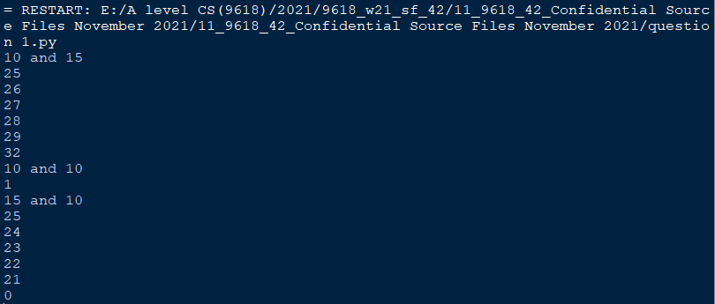

Part 1(c)
def IterativeUnknown(X, Y):
Total = 1
while X != Y:
print(str(X + Y))
if X < Y:
X = X + 1
Total = Total * 2
else:
X = X - 1
Total = int(Total / 2)
return Total

Part 1(d)(i)
print("Iterative code")
print("10 and 15")
print(str(IterativeUnknown(10, 15)))
print("10 and 10")
print(str(IterativeUnknown(10, 10)))
print("15 and 10")
print(str(IterativeUnknown(15, 10)))

Part 1(d)(ii)
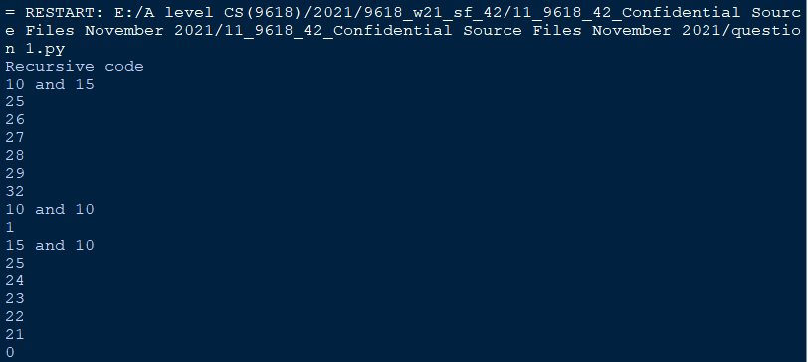
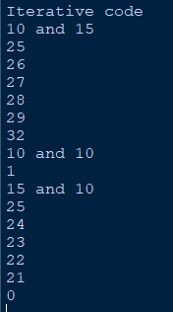

Question 2
Part 2(a)
class Picture:
def __init__(self, DescriptionP, WidthSizeP, HeightSizeP, FrameColourP):
self.__Description = DescriptionP #string
self.__Width = int(WidthSizeP) #integer
self.__Height = int(HeightSizeP) #integer
self.__FrameColour = FrameColourP #string

Part 2(b)
def GetDescription(self):
return self.__Description
def GetWidth(self):
return self.__Width
def GetHeight(self):
return self.__Height
def GetColour(self):
return self.__FrameColour

Part 2(c)
def SetDescription(self, DescriptionP):
self.__Description = DescriptionP

Part 2(d)
PictureArray = []
for i in range(100):
PictureArray.append(Picture("",0,0,""))

Part 2(e)
def ReadData(PictureArray):
Filename = "Pictures.txt"
Counter = 0
try:
File = open(Filename, "r")
Description = (File.readline()).strip().lower()
while (Description != ""):
Width = int((File.readline()).strip())
Height = int((File.readline()).strip())
Frame = ((File.readline()).strip()).lower()
PictureArray[Counter] = Picture(Description, Width, Height, Frame)
Description = ((File.readline()).strip()).lower()
Counter = Counter + 1
File.close()
except IOError:
print("Could not find file")
return Counter, PictureArray

Part 2(f)
NumberPicturesInArray, PictureArray = ReadData(PictureArray)

Part 2(g)
FrameColour = input("Input the frame colour ").lower()
MaxWidth = int(input("Input the Maximum Width "))
MaxHeight = int(input("Input the Maximum Height "))
print("Matches Frames shown")
for Z in range(0, NumberPicturesInArray):
if PictureArray[Z].GetColour() == FrameColour:
if (PictureArray[Z].GetWidth() <= MaxWidth):
if (PictureArray[Z].GetHeight() <= MaxHeight):
print(PictureArray[Z].GetDescription(), " ", str(PictureArray[Z].GetWidth()), " ",str(PictureArray[Z].GetHeight()))

Part 2(h)
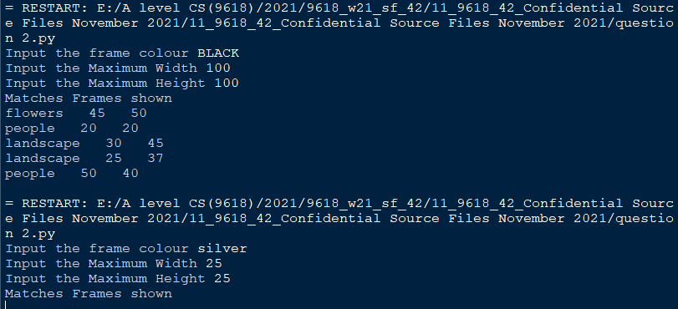

Question 3
Part 3(a)
ArrayNodes = [[0 for X in range(3)]for Y in range(20)]
RootPointer = -1
FreeNode = 0

Part 3(b)
def AddNode():
global ArrayNodes, RootPointer, FreeNode
NodeData = int(input("Enter the Data"))
if FreeNode <= 19:
ArrayNodes[FreeNode][0] = -1
ArrayNodes[FreeNode][1] = NodeData
ArrayNodes[FreeNode][2] = -1
if RootPointer == -1: #Add to start
RootPointer = 0
else:
Placed = False
CurrentNode = RootPointer
while Placed == False:
if NodeData < ArrayNodes[CurrentNode][1]:
if ArrayNodes[CurrentNode][0] == -1:
ArrayNodes[CurrentNode][0] = FreeNode
Placed = True
else:
CurrentNode = ArrayNodes[CurrentNode][0]
else:
if ArrayNodes[CurrentNode][2] == -1:
ArrayNodes[CurrentNode][2] = FreeNode
Placed = True
else:
CurrentNode = ArrayNodes[CurrentNode][2]
FreeNode = FreeNode + 1
else:
print("Tree is full")

Part 3(c)
def PrintAll(ArrayNodes):
for X in range(0, 20):
print(str(ArrayNodes[X][0]), " ", str(ArrayNodes[X][1]), " ", str(ArrayNodes[X][2]))

Part 3(d)(i)
for X in range(0, 10):
AddNode()
PrintAll(ArrayNodes)

Part 3(d)(ii)
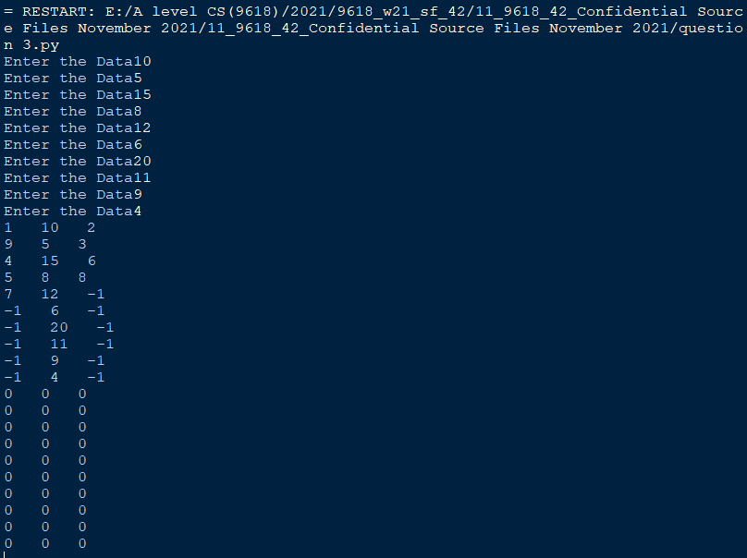

Part 3(e)(i)
def InOrder(ArrayNodes, RootNode):
if ArrayNodes[RootNode][0] != -1:
InOrder(ArrayNodes, ArrayNodes[RootNode][0])
print(str(ArrayNodes[RootNode][1]))
if ArrayNodes[RootNode][2] != -1:
InOrder(ArrayNodes, ArrayNodes[RootNode][2])

Part 3(e)(ii)
Code:
InOrder(ArrayNodes, RootPointer)

Screenshot:
